Git and GitHub

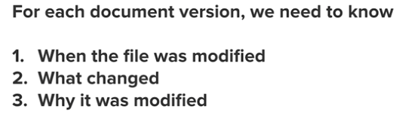

And 4. Who did the change

* Setup:

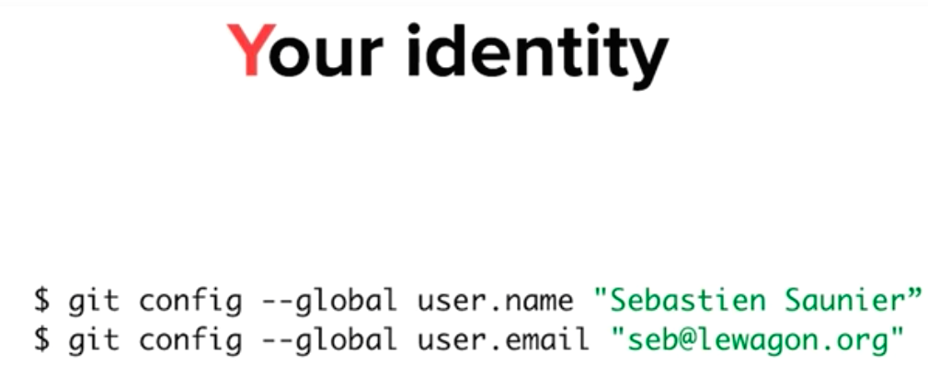

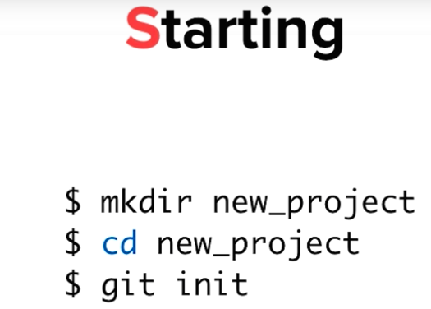-

git init – creates empty folder .git that tracks the changes

* git status – what has been changed inside the folder since last time
* Making a commit – 2 – step process

Selecting which files to commit by :

$git add <filename_1>

$git add <filename_2>

then take a snapshot of what is in the staging area - commits the added files to the repository

$git commit –message “ “

